GREAT HARWOOD AGRICULTURAL SHOW

SATURDAY 4th JUNE 2022

CLASSIC AND VINTAGE VEHICLES

LANCASHIRE VEHICLE CLUB
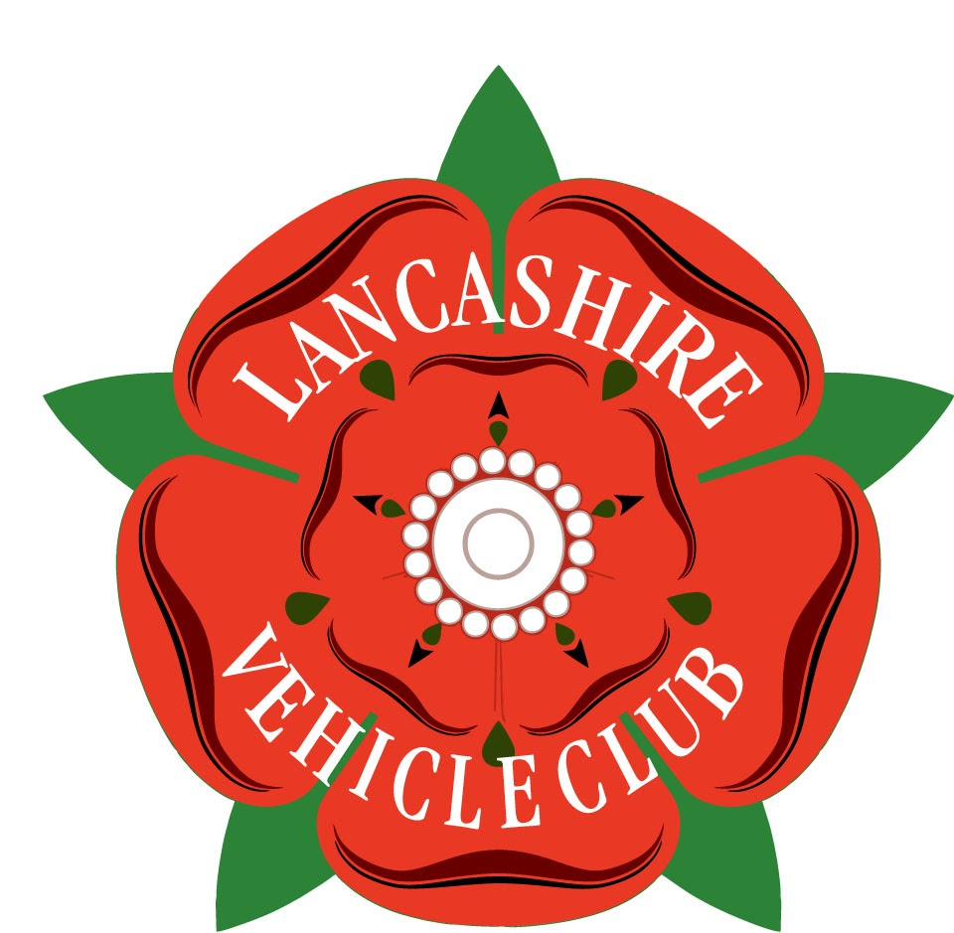
Application form for entry pass

Classic and vintage motor vehicles are exhibited free of charge at the show. The driver and one passenger will be allowed free access to the whole agricultural show.

Great Harwood Agricultural Show is a very interesting event with many different attractions to suit all age groups.

The website for the show is - greatharwoodshow.com

All vehicles brought to the show must have third party insurance. Exhibitors must comply with requests by the show stewards in relation to the positioning of their vehicle.

Vehicles should arrive between 8.30 am and 10 am on the day of the show.
I will send further details and entry passes in April.
Exhibitor’s name ……………………………………………………………...……...

Address ………………………………………………………………………………..

Email address …………………………………………………………………………

Phone no. ……………………………………………………………………………...

Signature ………………………………………. Date …………………………..
Make and model of vehicle …………………………………………………………..

Reg. no. …………………………….. Year ………………………………………

Please return completed forms by email by 31st March 2022
(but earlier if possible) to: -
andrewjwhittaker@hotmail.co.uk

or by post to: Andrew Whittaker, 4 The Croft, Euxton, Chorley, PR7 6LH.

Any queries please contact Andrew on - 07920 885169

